Ministry of Trade & Economic Development
2020 – 2021
ANNUAL
REPORT

Table of Contents
LIST OF ABBREVIATIONS 1
Foreword from the Minister 2
message from the ceo 3
A. OVERVIEW OF THE MINISTRY 4
A.1 Organisational Structure 4
A.2 Economic anaysis 5
A.3 private sector 5
A.4 Exports/trade 6
A.5 SDG Goal 8 – Decent work and Economic Growth 7
A.6 Summary of MTED Planned Major Reform Programs 7
A.4 MTED RESULT MAP 11
A.5 A SNAPSHOT OF MTED 12
Program 1: LEADERSHIP AND CORPORATES SERVICES 13
1.1 HUMAN RESOURCES 14
AND MANAGEMENT 14
1.1.1 Number of Staff and Composition 14
1.1.2 Staff Performance 16
1.1.3 Staff Movements 16
1.1.4 Staff Development and Trainings 17
1.2 FINANCIAL REPORT 18
AND SUMMARY 18
1.2.1 Statement of responsibilities 18
1.2.2 Budget Transfers 18
1.2.3 Asset registry 19
1.2.4 Actual Expenditure by division 21
1.2.5 Budget by catecory 22
1.2.6 COVID 19 BUSINESS RELIEF FUND 23
Program 2: policy and planning 24
2.1 KEY DELIVERABLES/ACHIEVEMENTS 25
2.1.1 Public Private Partnership 25
2.1.2 Public Updates 25
2.1.3COVID-19 Business Support Funds 25
2.1.4 Trade Week 25
2.1.5 Planning and Reporting Requirements 26
2.1.6 Arbitration Bill & Foreign Investment Regulations 26
2.1.7 WTO Notifications Obligations 26
2.2.8 Tonga Trade Policy Review to WTO 26
2.2.10 WTO Trade Facilitation Agreement 27
2.2.12 Pacific Island Forum Secretariat 27
2.2.13 PACER PLUS 27
2.2.14 Tonga Trade Policy Framework & E-commerce Readiness Assessment 28
2.2.15 E-Commerce project 28
2.2.16 Cross-Border Paperless Trade Training 29
2.2.17 Tonga National Trade Negotiation Committee (TNTNC) 29
2.2.18 High Level Meetings 29
Program 3: business registry & intellectual property 30
The Business Registry & Intellectual Property has four (4) subprograms with the following functions as follows; 30
3.1 KEY DELIVERABLES/ACHIEVEMENTS 31
3.1.1 BUSINESS REGISTRATION 31
3.1.2 Trademark Registry 32
3.1.3 Ongoing work 32
Program 4: business SUPPORT 33
4.1 KEYDELIVERABLES/ACHIEVEMENTS 34
4.1.1 Developed, established and registered five (5) Farmers’ Cooperative Societies (FCS). 34
4.1.2 Delivered Farmers’ Cooperative Societies Empowerment Programs (FCSEP) to five (5) Farmers’ 34
4.1.3 Deliver Capacity Building Programs through Trainings to micro MSMEs in the Informal Sector. 34
4.1.4 Developed and deliver MSMEs Product Development Projects for MSMEs. 34
4.1.5 COVID-19 Business Recovery Assistance. 34
4.1.6 Deliver Capacity Building Programs through Trainings to micro MSMEs in the Informal Sector. 34
4.1.7 Deliver Tonga Made Business Development Projects to local manufacturing businesses. 35
4.1.8 Deliver Business Support Assistances to Local Businesses. 35
4.1.9 Marketing and Promotion of Local Businesses (Tonga Made) 35
4.1.10 Development of new Pack Houses and renovations of existing Pack houses for processing and packing of exports. 36
4.1.11 Facilitate the delivery of Exporters Local Freighting Subsidy Scheme (ELFSS) for local Exporter Companies. 36
4.1.12 Processing and Exporting produce from Farmers to Export Markets. 36
Program 5: LABOUR 37
5.1 KEY DELIVERABLES/ACHIEVEMENTS 38
5.1.1 Approval of the Employment Relations Bill 2020. 38
5.1.2. SPECIAL CONSIDERATION FOR EMPLOYMENT VISA DURING COVID-19 LOCKDOWN. 38
5.1.3 Development of a National Employment Policy for Tonga. 38
5.2.1. Development of a Labour Market Information System (LMIS) for Tonga. 38
5.3.1. Ratification of the International Labour Organization's Worst Forms of Child Labour Convention (C182). 39
5.3.2. International Labour Organization (ILO) key projects. 39
Program 6: consumer protection & fair trade 40
6.1 KEY DELIVERABLES/ACHIEVEMENTS 41
6.1.1 Public Awareness programs on Consumer Responsibilities and Rights 41
6.1.2 A Program for the enforcement of Price Control, Weight and Measures and Consumer Protection Act is developed and implemented 41
6.1.3 Review of the Bus Fare Rates and Taxi Rates. 41
6.1.4 World Consumer Day 42
6.1.5 Tonga Competent Authority closely monitor the Petroleum and LPG Prices 42
Program 7: trade & investment 43
7.1 KEY DELIVERABLES/ACHIEVEMENTS 44
7.1.1 Exporter Needs Assessment Survey 44
7.1.2 Profiling of investment opportunities project-Investment Promotion & Facilitation Strategy 44
7.1.3 Pacific FDI Study 44
7.1.4 pacer plus agreement 44
7.1.5 Tonga Trade Policy Framework & E-commerce Readiness Assessment 45
Significant Issues and Challenges 46
Disclosure and Legal Compliance 47
Conclusion 48
Annex 1: Ministry’s Legislations 49

LIST OF ABBREVIATIONS

ADB : Asia Development Bank
AfT : Aid for Trade
AGO : Attorney General’s Office
ASYCUDA : Automated System Customs Data
BTM : Buy Tonga Made
CEO : Chief Executive Officer
CIIE : China International Import Expo
COVID-19 : C0- Corona, VI – Virus, D – Disease, 19 – 2019 (2019 novel coronavirus)
CSD : Corporate Services Division
DWCP : Decent Work Country Program
EIPO : World Intellectual Property Organization
ERAC : Employment Relations Advisory Committee
FYMP : Financial Year Management Plan
HOD : Head of Divisions
IEPA : Interim Economic Partnership Agreements
ILC : International Labour Conference
ILO : International Labour Organisation
ILS : International Labour Standards
KPI : Key Performance Indicators
LPG : Liquefied Petroleum Gas
MSME : Micro, Small, and Medium Enterprises
MTED : Ministry of Trade and Economic Development
OIC : Officer in Charge
PHAMA : Pacific Horticultural and Agricultural Market Access
PICTA : Pacific Island Countries Trade Agreement
PIFS : Pacific Islands Forum Secretariat
PMS : Performance Measurement System
PPD : Public Private Dialogue
PPSA : Personal Property Security Act
PTI : Pacific Trade Investment
QSMH : Queen Salote Memorial Hall
RIPO : Registry and Intellectual Property Office
RoO : Rules of Origin
RSE : Recognised Seasonal Employer
SWP : Seasonal Worker Program
TFA : Trade Facilitation Agreement
TNTCC : Tonga National Tripartite Consultation Committee
TNZTP : Tonga New Zealand Tourism Partnership
TPR : Tonga Policy Review
TSDF II : Tonga Strategic Development Framework II
TTPF : Tonga Trade Policy Framework
UNCTAD : United Nations Conference on Trade and Development
WBG : World Bank Group
WTO : World Trade Organisations

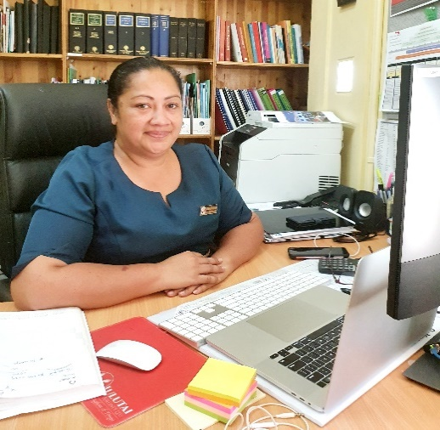

Foreword from the Minister

It is with great pleasure, that I submit the Annual Report of the Ministry of Trade and Economic Development (MTED) for the financial year July 2020 – June 2021. The challenges brought forth by the world-wide global pandemic COVID-19, has resulted in vast changes in the business environment, however the Ministry continues to focus its resources in responding effectively to the development, trade and commercial needs of the Kingdom.

The Ministry’s reforms are aimed to create an enabling business environment, facilitate increasing trade, sustainable commerce, consumer protection, and a more effective labour market to strengthen linkages to the Tonga Strategic Development Framework for a “a more progressive Tonga, supporting a higher quality of life for all, through more inclusive and sustainable economic growth and development”.

I acknowledge the combined efforts of development partners, government expertise across the civil service, the former Minister for Trade and Economic Development, Hon. Samiu Vaipulu and the CEO and staff of MTED for their dedication and commitment, which has resulted in a successful financial year 2020-2021.

There will be new challenges as we move ahead, however I look forward to another year of close collaboration with all stakeholders, supported by our ultimate call as civil servants to serve God, by serving others.

Respectfully,

………………………………………………
Hon. Tatafu Moeaki
Minister for Trade and Economic Development

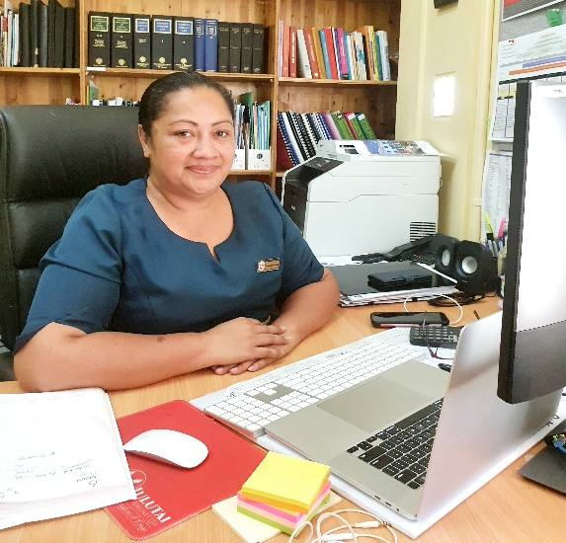

message from the ceo

This report is prepared in accordance with section 13 F of the Public Service Act and captures the key deliverables and achievements of the operation of the Ministry for the financial period 2020-2021. The report reflects the ministries core functions and legislations, financial statements of receipts and payments, organizational structure and assets and lastly, the ministry achievements and initiatives in delivering its services to its stakeholders.

The ministry continues to strive to improve our business environment in order to promote a more inclusive, sustainable and dynamic, knowledge-based economy. This includes the implementation of support programs in order to build the productive capacity of local businesses, having targeted support programs that increase and diversify Tongan exports amongst other MTED initiatives.

Work undertaken in the 2020-2021 financial year would not have been possible without the support and leadership of the former minister for MTED Hon. Samiu Kuita Vaipulu and the current minister Hon. Tatafu Moeaki who assumed office on 25th January, 2021.

The united and focus efforts of the Ministry of Trade & Economic Development staff, together with relevant stakeholders, has resulted in another successful and productive year. We look forward for the year ahead and continue to ask for God’s wisdom and guidance in order for the ministry to achieve its core functions.

Respectfully,

…………………………………..
Distaquaine Tu’ihalamaka
Chief Executive Officer
Ministry of Trade and Economic Development

OVERVIEW OF THE MINISTRY

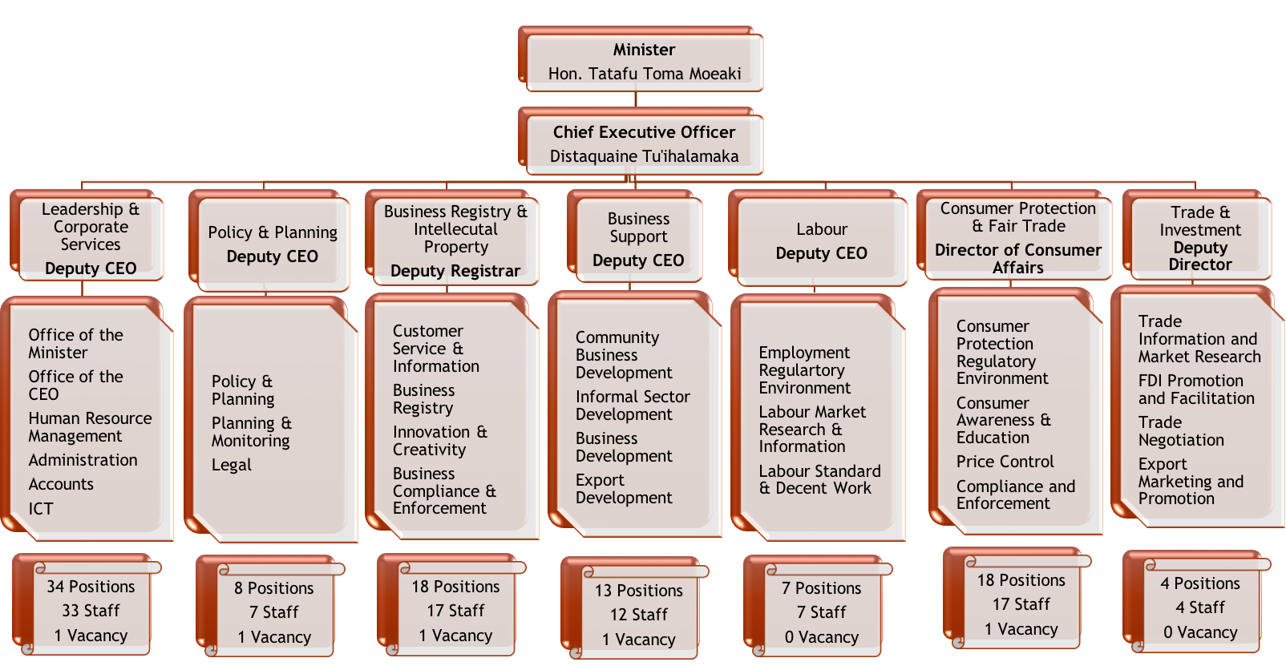
A.1 Organisational Structure

A.2 Economic anaysis

It was evident that the impacts of COVID-19 continued to affect Tonga’s economy in 2020/21 financial year (FY), particularly its key economic sectors – tourism, agriculture and fisheries. According to projections by the Ministry of Finance, Tonga’s economy worsened to a negative GDP growth of 2.5% in 2020/21 from negative 0.8 in the previous year, largely attributed to the prolonged impacts of COVID-19.

For instance, the main contributors to the negative economic performance in 2020/21 included a negative growth of 9.3% in the agriculture sector alongside severely weakened tourism-related activities due to impacts of COVID-19 on access to finance and international markets, in addition to climate change impacts.

In addition, the Government remains at a deficit budget in 2020/21 due to the impact of COVID-19 on revenue streams and consequently rationalization of expenditure. Nevertheless, MTED in coordination with other government ministries continued to offer assistance through the Government’s T$60m COVID-19 stimulus package to those most affected by the impacts of the pandemic, including local businesses, those in the agriculture, tourism, fisheries and in the informal sector.

Furthermore, the resilience in the level of remittances and an accommodative monetary stance by the National Reserve Bank of Tonga have helped to also support domestic demand in the midst of the pandemic.

A.3 private sector
The national rapid assessment on the impact of COVID-19 on business and employment identified significant negative impacts on business revenue with almost two thirds of formal business experiencing significant revenue decreases particularly in March – June 2020.

The informal sector was found to be relatively more resilient with most businesses experiencing moderate revenue increases.

On 10th March 2021, Cabinet Memorandum No.189 further approved a Phase 3 of the Business Recovery Assistance Program and allocated TOP7million for the provision of the following programs:

- Business Support Fund
- Employee Wage Subsidy
- Informal Business Support
The Ministry of Trade & Economic Development introduced new initiatives to assist affected businesses and employees, namely the Business Partnership Support Program and the Unemployment Registration Program. The Business Partnership Support Program was provided as part of the Ministry’s ongoing work of providing business advisory, mentoring, training, and outsourcing activities to assist businesses. The Unemployment Registration Program includes a registry of unemployed workers seeking employment and a process to match them with businesses seeking workers. Compared to the 2019/2020 FY, last FY 2020/2021 recorded an increase in all different registries by 906.

A.4 Exports/trade
The primary sector has shown resilience amidst a weakened economy due to the devastation impact of Covid-19. The sector is estimated to contract by 8.7 percent in FY 2021, from the strong growth of 4.5 percent in FY 2020 and 3.6 percent in FY 2019. The contraction is primarily due to the significant drop in the volume of squash exports, the adverse impacts of COVID-19 on borders and markets which affected the fishing industry especially the export of fresh fish. Government support through the COVID-19 stimulus package has strengthened domestic production of root-crops and assists in maintaining some of the domestic fishing boats to operate during this hard time. The sector is expected to recover at an average growth rate of 2.5 percent in the medium term up to FY 2025.

• Agriculture and Forestry: The agriculture sub-sector contracted by 9.3 percent in FY 2021 as compared to the strong growth of 5 percent in FY 2020. The weakening in growth is attributed mainly to the huge decline in squash production by approximately 300 acres in comparison to the norms. The situation was further exacerbated by the impacts of COVID-19 on farmers’ access to finance and market. The number of growers in the current financial year FY 2021 and FY 2022 is expected to decline significantly. On the other hand, the Government Stimulus Package supported the sector through subsidization of ploughs and seedlings which positively contributed to domestic production of traditional root-crops. The package also improved food security and export of access supplies to Tongan families abroad particularly in New Zealand and Australia.

In the first six months of FY 2021, the export volume of root crops especially cassava increased by 12 percent points when compared to the same period in FY 2020. The watermelon production was and is considered as the new niche product to offset the decline in the squash industry. However, the quarantine issue for watermelons hampered this effort. The pathway to the New Zealand market is therefore going through trials which will open the New Zealand market and possibly other neighbouring countries if the trial process is successful.

A.5 SDG Goal 8 – Decent work and Economic Growth
The Ministry contributes to the TSDF II vision of creating a more progressive Tonga supporting a higher quality of life for all. It aims to work towards the achievement of the national commitment to stimulating and promoting a more inclusive, sustainable and dynamic knowledge-based economy It contributes to the achievement of the national outcome through the following these three (3) organizational outcomes
This contributes to the achievement of the three organizational outcomes mentioned above through seven (7) key organizational outputs:
- Efficient and effective organization in delivering its outputs with the available resources
- Closer and effective public/private partnership that supports economic growth;
- An enabling business environment that is conducive to inclusive, sustainable and resilient economic growth;
- Targeted support programs that builds the productive capacity of local businesses;
- A labour market conditions and standards that support business growth, decent work and higher labour participation in both the formal and information sector; and
- A robust consumer protection and fair-trade regime that shapes consumer and business behaviour.
- Support programs that increase and diversify Tongan exports and promote Foreign Direct Investment (FDI).

A.6 Summary of MTED Planned Major Reform Programs
The Ministry, having taken into account the government priority agenda (GPA) in the budget strategy and funding envelop 2020/2021 with the theme, “Stronger Partnerships for a more inclusive growth and sustainable Tonga”. The ministry has redesignated its organizational structure, outputs and activities together with new initiatives to align to the national government plan and GPA. The status of the initiatives proposed in the beginning of the 2020/21 FY is tabled below;
PROGRAM | SUB – PROGRAM | ACTIVITIES | Traffic Light Assessment  Not Completed/ Ongoing/Completed
Program 1: Leadership & Corporate Services | Accounts | Renewal of Main Office | Ongoing- Technical documents regarding the removal of the Asbestos roof, costing and drawings have been provided by MOI. This will be processed to Central Procurement Unit early in July, 2021.
 | Human Resources | Staff Wellbeing Promotion | Ongoing
 | Administration | Renovation of main office | Ongoing – General maintenance in ongoing.
 | ICT | Website Development | Ongoing - Revamped Website Scheduled to be completed by August, 2021.
Program 2: Policy & Planning | Policy & Partnership | Trade and Economic Development Week | Completed - Cabinet approved the proposed Trade Week to be held on the 24 – 27 August, 2021 and led by the Ministry of Trade and Economic Development. Theme for the event is "Investing in Tonga's Economic Recovery". Stakeholders will be inviited to participate including other Government Ministries, NGOs and private sector.
Program 3:  Business Registry & Intellectual Property | Business Registry | Foreign Investment Act and Regulations | Foreign Investment Act is completed, Regulations are still being drafted.
 |  | Arbitration Act and New York Convention Treaty | Completed
 |  | Cooperative Society Act Review & Amendment | FY2021/22-FY2022/23 - Ongoing
 |  | Credit Union Act Review and Amendment | FY2021/22-FY2022/23 – Not applicable as this is done by NRBT
 |  | Upgrade of Business Online Registration System to facilitate online payment gateway and Foreign Investment Registry | FY2020/21-FY2022/23 - ongoing
 |  | Electronic Inspection Monitoring System (Tracking) | FY2020/21-FY2022/23 - ongoing
 |  | Review and amendment of the Industrial Property Act and Regulation | FY2021/22-FY2022/23 - Ongoing
Program 4: Business Support | Community Business Development | Establish of new Primary Farmers Cooperatives and development of empowerment scheme for Farmers Cooperatives. | Ongoing - FY2020/21-FY2022/23
 | Informal Sector Development | Credit Union and Micro Finance Development Project | Ongoing- FY2020/21-FY2022/23
 | Export Development | Renovate and upgrade existing Pack Houses in 'Eua and Vava'u. | Ongoing – deferred to 2021/22 FY
 |  | Building of new District Pack House for the Hihifo District. | Completed
 |  | Building of a new Tonga Market Base in Apia Samoa. | Ongoing – differed to 2021/22 FY
Program 5:  Labour | Employment Regulatory Environment | ERB 2019 implementation (subject to ERB being approved) | FY2020/21 ERB 2019 was approved by Parliament. The ERA 2020 has been tabled to the Privy Council for royal assent before it can be enacted. Implementation is pending enactment.
 | Labour Market Information & Research | Tonga Labour Market Report | FY2020/21-FY2022/23 - ongoing
 | Labour Standards & Decent work | National Employment Policy (NEP) Framework. | FY2020/21-FY2022/23 Phase 1: Seminar with stakeholders completed. Key outcomes included, increased awareness of/and learnings on the key concepts and labour issues, and consensus from meeting to develop a NEP for Tonga to assist disasters recovery efforts and increase employment.
 |  | Implementation of Worst Forms of Child Labour Convention - C182 (subject to ratification approval) | FY2020/21
Program 6:  Consumer Protection & Fair Trade | Consumer Institutional & Regulatory Environment | Strategy for the development and adoption of standards to protect consumers | Ongoing - joint program with Trade Division and Australian Standards ceased due to Covid 19 however continue work is carried out with the Quality Infrastructure Program with SPC
 |  | Development of the Consumer and Competition Policy | Ongoing - funding secured to implement in the 20221-2022 Financial year
 |  | Finalization of the Price Control Bill | Ongoing - Comments from ADB to be incorporated in the Bill before finalized
 | Price Control | Petroleum Reform Program | Ongoing
 | Enforcement & Compliance | Development of Legal Metrology and Weight and Measures Act | FY2020/21-FY2022/23
Program 7:  Trade & Investment | Trade Information & Market Research | Biennial Exporter Needs Assessment | FY2020/21-FY2022/23  Completed the Exporter Needs Assessment. Implementation of key recommendations in the report
 | FDI Promotion & Facilitation | Profiling of investment opportunities | FY2020/21-FY2022/23  Ongoing. Phase 1 of the project will be completed in August 2021. Phase 2 will convene and expected to complete in December 2021
 | Trade Negotiations | Ratification of PACER Plus Agreement | FY2020/2021-FY2022/23  Completed the ratification of PACER Plus Agreement. The Agreement entered into force on 13 December 2020
 | Export and Marketing Promotion | Export Marketing & Investment Promotion Representative in New Zealand & Australia | FY2020/21-FY2022/23  Ongoing

A.4 MTED RESULT MAP

A.5 A SNAPSHOT OF MTED

FINANCIAL & ASSET SUMMARY

APPROVED BUDGEGT - $6.9m
% OF EXPENDITURE – 93%
% OF REVENUE COLLECTION – 95%
ASSET REGISTRY- $1.46m
PROCUREMENT COMPLIANCE – 85%
COVID 19 ASSISTANCE – 9.2m
- 598 Registered Businesses
- Aprox. 6,800 Informal Businesses
- Aprox. 1150 Temporary Wage Subsidy
- New effective dates for the release on the monthly petroleum and LPG quarterly to move from the 15th to the 18th of every month

85
Tongatapu based
97
MTED Staff
12
Outer Islands
KEY DATA

47 company registrations
662 business licenses
18 foreign investors
69 incorporated society
1623 inspections conducted
297 complaints dealt with
12 micro MSME trainings
GRANTS

$70k 35 Micro MSME businesses
$44ok 5 Farmers Cooperative Societies
$115k 23 Tonga Made Product businesses

OTHER ACHIEVEMENTS

- Foreign Investment Act
- Employment Relation Bill
- PACER PLUS

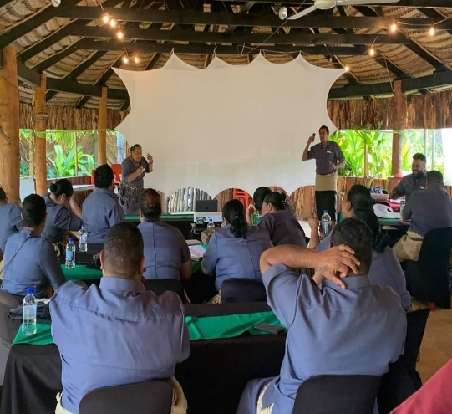

Program 1: LEADERSHIP AND CORPORATES SERVICES

The Leadership and Corporate Services program has six ( 6) subprograms with the following functions as follows; (highlight program 1)
  - Office of the Minister: Advice and guidance to stakeholders and oversee management and delivery of the Ministry’s programs;
  - Office of the CEO: Development, management and implementation oversight of MTED’s Corporate Plan and staff leadership
  - Human Resource: Staff recruitment, performance improvement and compliance
  - Administration: Internal operation policy and Management
  - Accounts: Establishment and facilitation of an improved financial management policy.
  - ICT: Appropriate ICT policy and service facilitating all communications and technology requirements of the ministry

Reforms Undertaken
- In the previous financial year 2019/20 FY, Leadership and Corporate Services program consisted of nine (9) sub-programs two of which were external outputs namely Policy and Enforcement. Sub-programs have now been focused purely on internal outputs as mentioned above.
- Two of the major sub-programs for Corporate Service is Human Resources and Financial Management which is further detailed later in this report.

Major Customers
The Key clients for Leadership and Corporate Services include the following stakeholders;
- MDAs
- Business (Suppliers)
- Divisions of the Ministry
- Cabinet
- Legislative Assembly
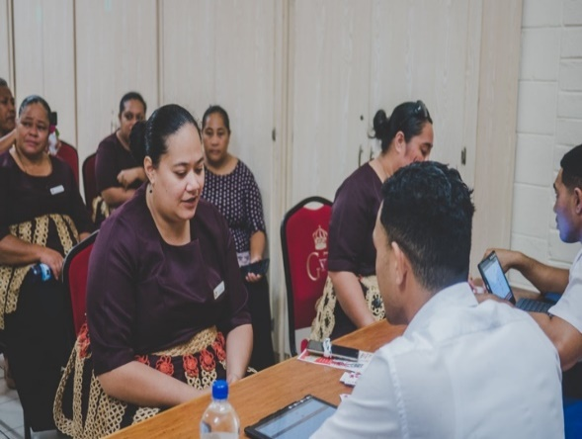

HUMAN RESOURCES

AND MANAGEMENT

The Ministry of Trade and Economic Development is under the Leadership and guidance of Hon. Tatafu Moeaki who assumed duty on the 25th January, 2021. The CEO, Mrs Distaquaine Tu’ihalamaka was appointed via four (4) years contract on the 23rd March, 2020 to 23rd March, 2024.
The Minister and CEO is supported by the following Head of Divisions tabled below;
Table 1 Divisions and Head of Divisions (HOD)/ Branches and Officers in Charge (OIC)
DIVISION | HEAD OF DIVISION / OFFICER IN CHARGE
Leadership and Corporate Services | Mr. Charles Lavemaau
Policy & Planning | Mrs. Lorraine Paasi Kauhenga
Business Registry and Intellectual Property | Mrs. Poinisetia Paongo
Business Support | Mr. Tevita Lautaha
Labour | Ms. Kolotia Fotu
Consumer Protection and Fair Trade | Mrs. Sandradee Fifita
Trade & Investment | Mrs. Pauline Siasau
Outer Islands Offices | Officer-In-Charge
Vava’u | Mrs. Lolina Tonga
Ha’apai | Mr. Sione Paletu`a
‘Eua | Mrs. Silia Tuai

Number of Staff and Composition
As of June 2021, the Ministry had a total of eighty-seven (87) permanent staff, ten (10) contracted daily laborers and five (5) vacant positions yet to be filled, partially due to recruitment restrictions imposed by PSC. The composition of staff by division is as follows

Division | Permanent Staff | Contract daily laborers | Vacancies | Gender
 |  |  |  | Male | Female
Leadership & Corporate Services | 29 | 4 | 1 | 15 | 18
Policy & Planning | 7 | - | 1 | 1 | 6
Business Registry & Intellectual Property | 17 | - | 1 | 7 | 10
Business Support | 10 | 2 | 1 | 6 | 6
Labour | 6 | 1 | - | 2 | 5
Consumer Protection & Fair Trade | 15 | 2 | 1 | 4 | 13
Trade & Investment | 3 | 1 | - | 1 | 3
Table 2 Staff Composition by Division/gender

Of the ten (10) daily paid positions, it is noted that some staff have attained professional qualifications, hence MTED is currently in the process of transitioning these employees to professional contracts. It is further envisioned that the five (5) vacant positions will be advertised next FY once approval is received from the Public Service Commission.
Furthermore, installation and implementation of the new Biometric Fingerprint Scanner within the Office has transformed the time attendance system from manual to a faster and more reliable way of capturing staff hours worked, including real time monitoring from head office of staff attendance in the other islands.
Gender Balance
Out of the 97-staff employed by MTED, it is mainly female dominated as shown below; It is further noted that the 37% of male employees is mostly made up of junior positions. Senior and top management positions are mostly dominated by females. This is apparent with only two (2) male HODs in comparison to the remaining five (5) female HODs.
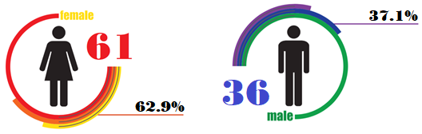

Staff Performance

The chart below shows a summary of staff performance results of the Ministry for the FY 2018/19 and 2019/20. The results for the 2020/21 FY will be reflected in the 2021/22 FY Annual Report as the results have yet to be finalized. Majority of the ministry for two (2) consecutive years have scored a rating of 3 which indicates that you have achieved your work targets. The rating of 4 and 5 indicates outstanding performance and as illustrated in the graph below, the PMS results shows a general improvement of the MTED performance compared to the 2018/19 FY.
Chart 1 Number of Staff per Performance Ratings from 2018/19 to 2019/20
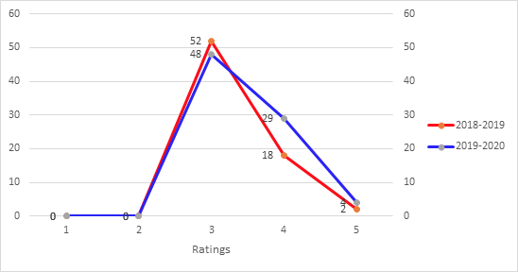

Staff Movements
During the financial year period, a number of staff were appointed, promoted and transferred to the Ministry as shown below. The following tables outlines the details of these movements:

New Appointments
 | Name | Post Title | Band | Effective date
1 | Ana Finau | Assistant Secretary | L | 18th January, 2021
2 | ‘Ana Takau | Personal Assistant to Minister | L | 24th February 2021
3 | Makai Pulu | VIP Driver | Q | 24th February 2021

Staff Promotions/Transfer
 | Name | Promotion Post | Band | Effective date
1 | Mrs. Poinisetia Paongo | Deputy Registrar | G | 9th February, 2021
2 | Mr. Charles Lavemaau | Deputy CEO | G | 29th March, 2021
3 | Ms. ‘Ilaisaane Tu’itupou | Principal Assistant Registrar | I | 31st May, 2021

Transfers within Government
 | Name and Title | Transfer to | Band | Effective date
1 | Sela Moa, Deputy Secretary | Ministry of Justice | H | 4th January, 2021
2 | Heamasi ‘Oto, VIP Driver | Ministry of Justice | Q | 25th January

Staff Development and Trainings

Training topic | Number of Staff
Job Descriptions | 3
Introductory to Data Analysis using Excel | 20
Internal Policy | 83
Customer Service | 2
Legislative drafting | 4
Records Management | 2
Negotiation and Mediation | 17
E-Academy on Labour Migration | 9
Intellectual Property Training | 4
Customer Training | 22
Due to the global pandemic of the COVID 19 there were no training programs provided for staff overseas. However, trainings are being provided virtually and the Ministry continues to engage local trainers as well as attending inter-ministry training programs, with the intentions of upskilling staff.
CORPORTE SOCIAL RESPONSIBILITY
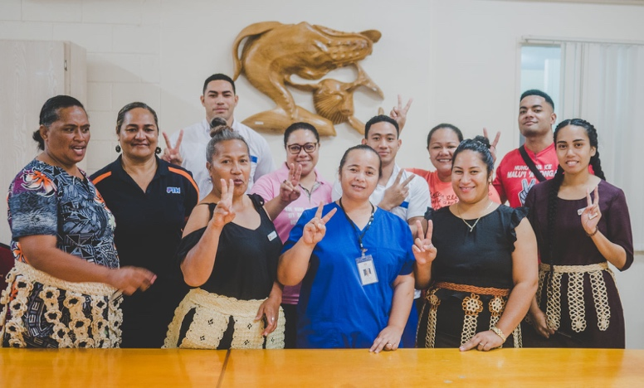
The Ministry values the wellbeing of its staff and continuously strives to give back to the community and further promote a healthy workforce.
Pinktober muftis – In the month of October 2020 the Ministry supported the breast cancer awareness and its “early detention save lives” movement with a pink mufti every Friday and a donation box which was collected and donated to the Breast Cancer Society.
COVID 19 vaccines - On May 5, 2021 the eighty-three (83) staff were vaccinated with the first dose of AstraZeneca. The Ministry fully supports the commitment of the Government to ensure safety of the public and country from the global pandemic of the COVID 19.
Inter-government sports: MTED Staff pictured below, supporting a healthy and fit workforce.

FINANCIAL REPORT

AND SUMMARY

1.2.1 Statement of responsibilities

The CEO of the MTED, including the Deputy CEO for Corporate Services and the head of the Accounts section together with supporting staff is responsible for the prudent management of the financial affairs of the Ministry, in close working partnership with the Ministry of Finance in the preparation of the budget documents, monthly forecasts and revenue collections. The financial statements of revenue expenditure is provided, subject to annual audits.

1.2.2 Budget Transfers
All budget transfers was processed according to the Public Finance Management Act 2020 specifically that “the amount transferred does not increase an appropriation for the financial year for that programme by more than 10 per cent”. It should also be noted that the substantial amounts transferred was supported by relevant Cabinet decisions regarding the sequestration of $250,000 to the Ministry of Finance vote to cater for the purchase of three (3) vehicles.

Expenditure Category | Budget | Transfers | Revised Budget | Actual | Remaining Bal
Established staff | $2,769,400 | -$338,755 | $2,430,645 | $2,430,425 | $219
Unestablished staff | $487,400 | -$364,938 | $122,462 | $101,976 | $20,486
Travel & Communication | $526,100 | -$206,009 | $320,091 | $312,614 | $7,477
Maintenance & Operation | $305,300 | $93,753 | $399,053 | $350,183 | $48,870
Purchase of goods & services | $2,523,700 | $577,709 | $3,101,409 | $2,729,599 | $371,809
Grants & Transfers | $133,000 | -$119,884 | $13,116 | $12,991 | $125
Assets | $247,400 | $108,124 | $355,524 | $328,346 | $27,178
Grand Total | $6,992,300 | -$250,000 | $6,742,300 | $6,266,135 | $476,165

Furthermore, $ 1 million was approved by cabinet to be sequestrated from MTED recurrent funds to Finance, where it was then redirected back to our recurrent funds specifically to the Community

Development Vote under Business Support Program 4, these funds where used to fund variouse business support request together with Covid-19 support pay-outs.
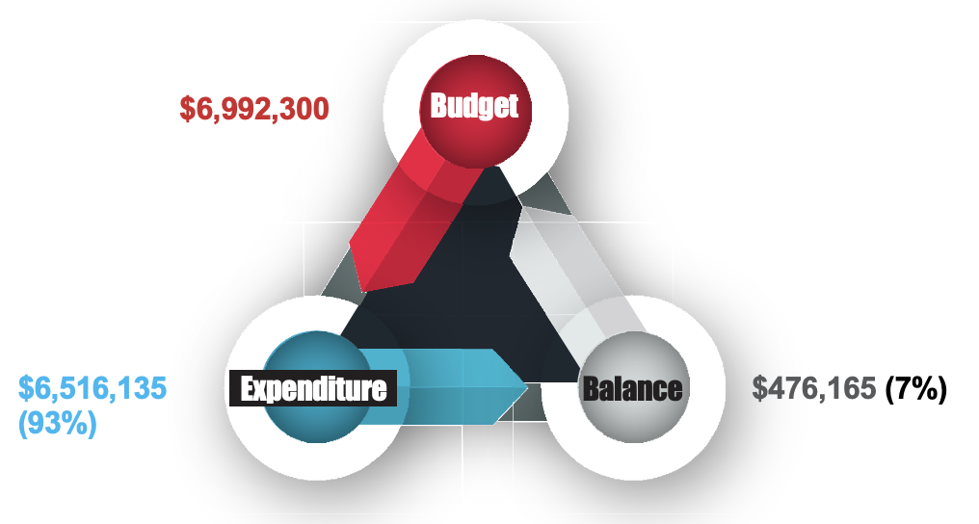
MTED reached over 90% of its total recurrent budget spent in 2020/2021, the highest proportion spent in the past 3 years. Compared to the last FY 2019/20, just below 70% was spent. Increase in spending in 2020/2021 was partly due to COVID-19 related assistance, but without it, the Ministry would have still spent well over 85% of its total budget. This signifies the continuous efforts of the Ministry in strengthening its role in economic development as part of its contribution to the overall strive of the country for a higher quality of life (TSDF II).

Summary of Asset Registered as 30th June, 2021
Description |  | Book Value $$$
Building |  | $166,101
Vehicles |  | $410,351
Computer Software |  | -
Computer Hardware |  | $196,159
Furnitures & Fittings |  | $352,515
Office Equipment |  | $203,649
Other Plant & Equipment |  | $131,185
TOTAL | $1,459,961

1.2.3 Asset registry
The MTED fixed assets has a total book value of $1,459,961 compared to $1,601, 163 in the 2019/2020 financial year. This 9% decrease is mainly due to the depreciation cost of computer hardware, furniture and fittings and Office equipment.

All fixed assets are disposed according to the relevant sections of the Treasury Instructions 2020.
It is further noted that the building cost has increased by 28% compared to 2019/2020 FY due to renovations and improvements conducted to the current building.

Ministry of Trade and Economic Development - Statement of Revenue and Expenditure for the year ended 30 June 2021

 | 2019-2020  ($) | 2020-2021  ($)
REVENUE TARGET | 672,000 | 672,000
Industrial Properties Registration | 185,752 | 160,779
Business License | 272,700 | 279,895
Company Registration | 153,243 | 152,366
Price Control/Weight & Measures | 37,785 | 39,423
Foreign Investment License | 8,945 | 9,285
Sales of Produce & Products | 3,500 | -
TOTAL REVENUE COLLECTED | $661,925 | $641,784
% REVENUE COLLECTED | 99% | 95%
Total Recurrent Budget | 8,139,800 | 6,992,300
EXPENDITURE
Established Staff | 2,351,940 | 2,430,425
Unestablished Staff | 165,040 | 101,975
Travel & Communication | 425,490 | 312,614
Maintenance & Operations | 259,424 | 350,183
Purchase of Goods & Services | 1,635,626 | 2,729,599
Grants & Transfers | 52,230 | 12,990
Capital | 424,592 | 328,346
TOTAL EXPENDITURE | 5,314,405 | 6,266,135
% OF EXPENDITURE | 65% | 93%

1.2.4 Actual Expenditure by division
93% Spent
The above graph illustrates the share of spending by each Program. For instance, out of the $6.5m total expenditure in 2020/2021, majority of it was spent under the Leadership program at 34%, followed by 32% at Business Support program. These two programs reflect the highest percentage of spending due to Program 1 having the most staff, also due to operational funds being centralized to this program such as Overtime.

The two divisions that spent most of their respective divisional budgets is Policy and Planning and Labour division. Business Support spent 86% of its budget with a remaining 14% remaining balance.

1.2.5 Budget by catecory

The graph above shows the original budget allocation and how much was actually spent in 2020/2021 by spending category. Evidently, spending on established staff continued to be the dominant category of which $2.4m was actually spent out of the originally estimated $2.8m. This reflects the continuous effort of the Ministry to recruit and maintain its manpower for delivering its key outputs. Secondly, the Ministry slightly spent more than its original budget allocation for purchasing of goods and services, mainly due to the COVID-19 related business support funding assistance together with assets for the new office in Vava’u.

Procurement
The ministry continues to follow Procurement Regulations regarding purchases above the procurement threhold. Of the seven (7) proposals submitted to the Central Procurement Unit six (6) proposals were endorsed as compliance with procurement regulations. The one (1) non-compliance proposal was due to the urgent need to destroy a container of watermelons that was exported to NZ that was contaminated. Hence given the time sensitive issue, the services of the company to destroy the container of watermelons was rendered prior to receiving procurement endorsement.
85% Compliance
Project Name | Amount | Supplier
Business Registries Online System (Application and Operational Support Services)  (Business Registry & IP Division) | NZ$55,440 (TOP$79,586) | Foster Moore (NZ) - Completed
Petroleum Fuel & LPG Price Review (Consumer and Fair Trade Division) | NZ$72,294 (TOP$103,781) | Hale & Twomey (NZ) – Completed
Purchase of three (3) New Vehicles | $250,000 | ASCO Motors
Extension of Vehicle Shed | $40,600 | MAC United Group Company Ltd - Completed
Note: Above table shows some of the procurement proposals processed during the financial year.

1.2.6 COVID 19 BUSINESS RELIEF FUND
SUMMARY OF FINANCIAL REPORT ON COVID 19 BUSINESSES RELIEF FUND PHASE 3 PROJECT PROCESS TO PAYOUT
Description/Islands | No of Process | Amount Process
Business Registry
Tongatapu | 159 | 3,267,000
Vava’u | 59 | 1,175,000
Ha’apai | 15 | 259,500
Eua | 2 | 2,500
Niuatoputapu | 1 | 1,000
Niuafo’ou | 0 | 0
TOTAL | 236 | 4,705,000
Informal Businesses
Tongatapu | 3886 | 1,943,000
Vava’u | 1612 | 806,000
Ha’apai | 548 | 274,000
Eua | 174 | 87,000
Niuatoputapu | 119 | 59,500
Niuafo’ou | 33 | 16,500
TOTAL |  | 3,186,000
Temporary Wage Subsidies
Tongatapu | 64 | 355,100
Vava’u | 6 | 16,000
Ha'apai | 0 | 0
Eua | 1 | 2,000
Niuatoputapu | 0 | 0
Niuafo'ou | 0 | 0
TOTAL | 71 | 373,100
TOTAL PROCESS TO PAYOUT |  | 8,264,100

SUMMARY OF FINANCIAL REPORT ON COVID 19 BUSINESSES RELIEF FUND PHASE 3 PROJECT ON ACTUAL PAYOUT
Description | Budget | Actual Payout | Actual % | Balance | Balance %
Grant Funds Issues | $8,240,950 | $8,152,950 | 99% | $88,000 | 1%

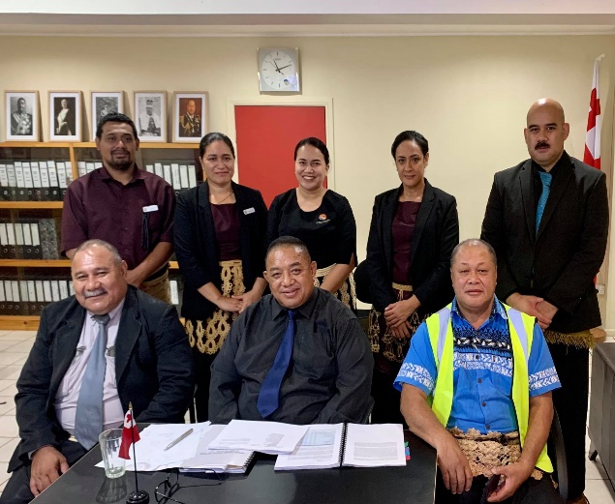

Program 2: policy and planning

The Policy and Planning program has three (3) subprograms with the following functions as follows;

2.1 Policy and Partnership: Provision of sound and evidence-based policy advice and support to the delivery of the Ministry organizational outputs.
2.2 Planning and Monitoring: Effective management plans and to derive performance improvement within the Ministry
2.3 Legal: Provision of legal advice and support to the delivery of the Ministries outputs.

Reforms Undertaken
- Policy & Planning overlooks all the planning requirements of the Office, which will slowly be transitioned to the Corporate Services division next FY, to allow the division to focus on Policy and Trade issues. The trade function was also shifted from Program 7 to the Policy division with aims for better alignment and efficiency.
- Legal unit was established to provide real time legal advice on general policy and trade matters regarding the Ministry;
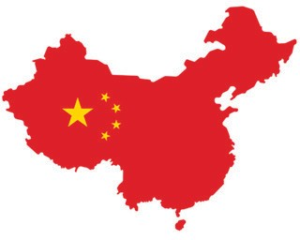
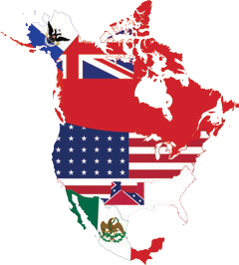

2.1 KEY DELIVERABLES/ACHIEVEMENTS

2.1.1 Public Private Partnership
Relationship with the private sector, specifically with the Tonga Chamber of Commerce and Industries (TCCI), have picked up again during this financial year, where the Ministry had been engaging the TCCI in various policy consultations. In addition, the Ministry and TCCI have have been in discussion to develop working arrangements to ensure private sector engagement is conducted. It is intended that a Memorandum of Understanding be signed with the TCCI and to outsource some of the activities that the Ministry is conducting to TCCI. But as a start, they will assist the Ministry in facilitating consultation platforms to enable public private sector dialogues. This will ensure collective private sector views ar taken into account in the government’s policy making processes, planning processes, and legislative reviews or proposals.
The Ministry was able to secure funding and assistance from the Asia Development Bank (ADB) through their Private Sector Development Initiative program, to conduct the very first Informal Sector Survey for Tonga. The survey will assist the Ministry and interested parties in identifying areas for development and support to empower and encourage informal businesses into a formal establishment. The Ministry is working closely with the ADB to ensure the success and usefulness of the survey.

2.1.2 Public Updates
The recruitment of Communications Officer was successful. The officer is to assist the Ministry with the development of a communications strategy, develop communications materials including press releases, announcements, website contents, and Facebook posts amongst others.

2.1.3COVID-19 Business Support Funds
The COVID-19 Business Support Fund program (Phase 3 - 5) was approved by Cabinet in March 2021. Phase 3 was launched March 17 with a budget of 9.2 million and was closed April 30. Applications for the funds were under 3 categories; Registered Business, Informal Business, and Temporary Wage Subsidy. 598 businesses applied for the Registered Business Fund, around 6,800 for Informal Business, and 147 businesses for the Temporary Wage Subsidy with around 1,150 employees. Disbursement of funds was still ongoing by the end of this Financial Year.
Other activities included financial support for export and manufacturing businesses, unemployment registration services and other business support services.
Conclusion of this program will be reported in the next Financial Year. Phase 4 and 5 is scheduled to be implemented in the next Financial Year as well.

2.1.4 Trade Week
Cabinet approved for the Ministry of hold its very first Trade Week, to be held 24 – 27 August 2021. Theme for the Trade Week is “investing in Tonga’s economic recovery”. Selected stakeholders will be invited to participate.

2.1.5 Planning and Reporting Requirements
- Corporate Plan, Procurement and Budget requirements for the 2020/21 FY was all due to Finance on time.
- Annual Reports for 2018/19 and 2019/20 FY was passed by LA on the 6th July, 2021.
- All Staff Retreat: Theme: “Our Island, Our People, Our Business” conducted on 31st,July, 2020.

2.1.6 Arbitration Bill & Foreign Investment Regulations
The Cabinet approval for the Arbitration Bill was one of the budget triggers and the deadline was 30th October, 2020. This trigger was successfully completed and the Arbitration Bill has been approved by Parliament and has now received royal assent.

The Ministry is currently preparing the draft of the Foreign Investment Regulation.DD

2.1.7 WTO Notifications Obligations

The division continued to update Tonga’s outstanding WTO notification obligations with eight (8) notifications submitted this FY. The following three (3) obligations were outstanding notifications during the FY2020/2021 and has now been completed
- Revised notification on the Trade Facilitation Agreement
- Quantitative restrictions
- Safeguard measures

2.2.8 Tonga Trade Policy Review to WTO

Tonga successfully conducted its 2nd Trade Policy Review to WTO on 14 and 16 April 2021. This was the second trade policy review for Tonga since Tonga became a WTO member. The first one was on the 11 and 13 February 2014. Tonga's policy review is every 7 years.
The review involved the development and finalising the Government of Tonga report with close consultations with relevant Ministries on a one-to-one basis, and coordinating the request for information from the WTO for the development of the Secretariat report for the WTO. The 2 reports were submitted to Cabinet for approval before the Trade Policy Review Meeting took place in April. The Honourable Minister was the Head of Delegation and other delegations included staff of the Ministry, CEO for Revenue and Customs, Acting CEO for Agriculture, Food and Forestry, senior staff from AGO and Foreign Affairs.
2.2.9 Agricultural Export Prohibitions or Restrictions relating to the World Food Programme (WFP)
Tonga supported the Joint Statement to co-sponsor Agricultural Export Prohibitions or Restrictions relating to the World Food Programme (WFP) - collective commitment to support the WFP in alleviating hunger and combating malnutrition among the world’s most vulnerable populations, especially during the COVID-19 pandemic.

2.2.10 WTO Trade Facilitation Agreement
The Ministry is making progress towards ratifying the WTO's Trade Facilitation Agreement. A trade facilitation implementation roadmap has been drawn to ensure Tonga's readiness when the agreement is ratified. One of the activities in the roadpam is being supported and funded by the World Bank. This is the Expedited shipment of essential goods, vaccines and ancillary medical equipment. This project is to assist all parties involved in clearing vaccines are aware of the processes and communicate effectively and efficiently to ensure the shift and proper clearance of vaccines, in preparation for the arrival of the COVID-19 vaccine. The end product will be a guideline document containing fact sheets and process map to assist all stakeholders on their clearance process.

2.2.11 Organization of the African
Tonga ratified the Revised Georgetown Agreement 7 April 2021 at OACPS Headquarters, Brussels - In ratifying the Agreement, Tonga reaffirms its commitment and support to further solidarity among the Member States of the OACPS during the global pandemic and to support the need to strengthen cooperation amongst our members, to successfully take full advantage of the global economy.

2.2.12 Pacific Island Forum Secretariat
The Ministry successfully coordinated the logistics for hosting the PIFS – ITC Symposium on Trade Finance 10-11 March 2021, a total of 22 participants from Tonga joined the symposium.
Tonga Fisheries and Trade Officials virtually participated in the briefing on the Fisheries subsidies Negotiations by the PIF Geneva Office 20 May 2021.

2.2.13 PACER PLUS
The Pacific Agreement on Closer Economic Relations (PACER Plus) was launched in Tonga on 14 June 2017. It is a regional Free Trade Agreement and it entered into force 13 December 2020. Parties to the agreement are Australia, Cook Islands, Kiribati, New Zealand Niue, Samoa, Solomon Islands and Tonga. Nauru, Tuvalu and Vanuatu signed the agreement but have not yet ratified to become a party to the agreement.
The following projects are under this agreement was carried out:
- Finalization of the PACER Plus Summaries and Guidelines by consultancy agent (Chapman Tripp) in collaboration with the Ministry and stakeholders. This will be useful documents for Government Officials and the general public in better understanding the Agreement.
- Update of the Tonga Trade Portal – A step by step guide of trade procedures to assist importers and exporters in their trading processes;
- Outer-island Outreach program completed Vava‘u 16-18 June, Ha‘apai 23-24 June and ‘Eua 6 July– to provide businesses and potential exporters with information regarding the agreement ;
- Consultation on the Rapid Needs Assessment – convened sectoral consultations with government and Non-State Actors to identify Tonga’s priority activities (needs) required for the effective implementation of the agreement;
Joint Committee Meeting/Subsidiary Meetings – Tonga participated in these meetings and Tonga chaired the second Joint Committee Meeting. The Joint Committee Meeting is the decision-making body on the implementation of the agreement; and the Implementation Unit- the set-up of this unit is near completion. It is located in Samoa and a Head of the Unit has been selected and is to commence duty on July 5.

2.2.14 Tonga Trade Policy Framework & E-commerce Readiness Assessment
The Division successfully launched the Tonga Trade Policy Framework and E-commerce Readiness Assessment for Tonga in August, 2020. This Trade Policy Framework provides a structural context on how Tonga will manage its commercial activities in the country and with trading partners. It focuses in repositioning Tonga’s socio-economic development envisaged in the TSDF that contributes to the implementation of Tonga’s commitments on Trade related SDGs 8,9,14.6 and 17. The E-commerce Readiness Assessment was developed to provide an analysis of the current e-commerce situation, identify key constraints both internal and external, assess current strategies, weaknesses, gaps and opportunities. It also provides key policy reforms for Tonga to consider as they are keys to ensure Tonga is ready to trade in the e-commerce world.

Hon Pōhiva Tuʻiʻonetoa Prime Minister and Hon Mr Adrian Morrison, Australia High Commissioner to Tonga presided over the launching of the National E-commerce Assessment of Tonga and Tonga Trade Policy Framework. Credit: Pacific Islands Forum.

2.2.15 E-Commerce project
The Ministry of Trade and Economic Development has secured funding under the Government of Australia’s ​e-Commerce Aid for Trade Fund ​to assist the Government of Tonga with a project known as ‘Strengthening an Inclusive Enabling Environment for e-Commerce.’ In partnership with TradeWorthy Ltd, a DFAT grantee, this one-year project is aimed at the; (i) development of a National Digital Economy Roadmap, (ii) development of a Roadmap on E-Commerce Legal Framework, (iii) capacity building for Tonga’s Cross-Border Digital Trade commitments and (IV) development of local expertise on e-commerce policy among the project team​. The project is expected to conclude in August.

2.2.16 Cross-Border Paperless Trade Training
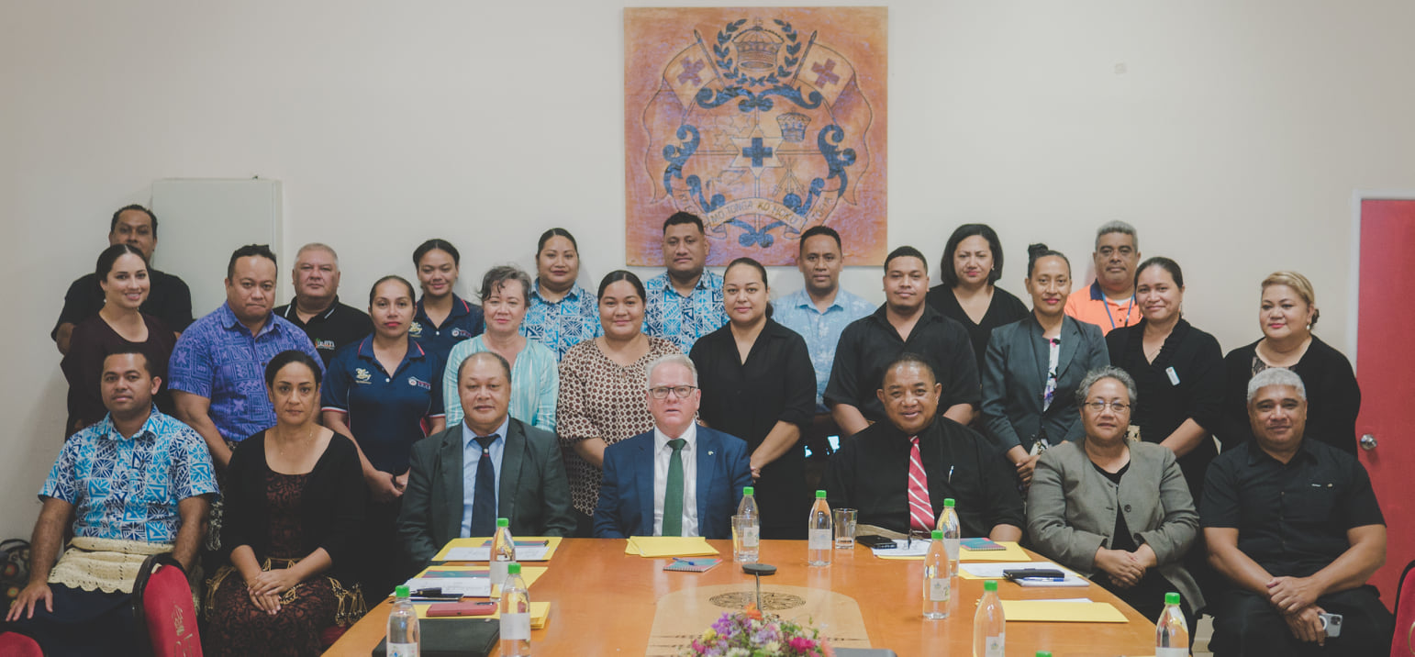
The Ministry launched the Cross-Border Paperless Trade Training Programme on the 5th May 2021. This was the first in 7 modules of trainings provided in May and June. Participants were introduced to what Cross-Border Paperless Trade is. Welcoming remarks were given by Honorable Tatafu Moeaki, Minister of Trade and Economic Development, followed by Australian High Commissioner Adrian Morrison and Mr. Kelemete Vahe, CEO for the Ministry of Revenue and Customs. Also, in attendance via zoom was Sven Callebaut (international e-commerce consultant), Ms. Soo Hyun Kim from UNESCAP, local TradeWorthy consultants, Senior officials, Shipping agencies, Custom Brokers, Exporters and Importers.

2.2.17 Tonga National Trade Negotiation Committee (TNTNC)
The committee had its first meeting March 24, 2021, after being inactive for some time. This is a milestone in terms of ensuring increased collaboration, understanding and communications are developed and maintained between Ministries involved on trade related matters. Decisions made on issues presented to the Committee will guide the members on their implementation plan on that particular issue.
Members of the committee include Chief Executive Officers of the following Ministries: Trade & Economic Development; Foreign Affairs; Agriculture, Food and Forest; Revenue and Customs; Fisheries; Finance; Internal Affairs; Meteorology, Energy, Information, Disaster Management, Environment, Climate Change and Communications; and the Governor of the National Reserve Bank of Tonga. The Minister for Trade and Economic Development is the Chair and the Policy and Planning Division serves as the Secretariat.

2.2.18 High Level Meetings
The Ministry participated in the following high-level meetings:
- PACER Plus Ministerial Meeting, 30 June 2021 (chaired by Tonga, Minister for Trade and Economic Development)
- Special Virtual PACP WTO Trade Minister’s Meeting, 22 June 2021

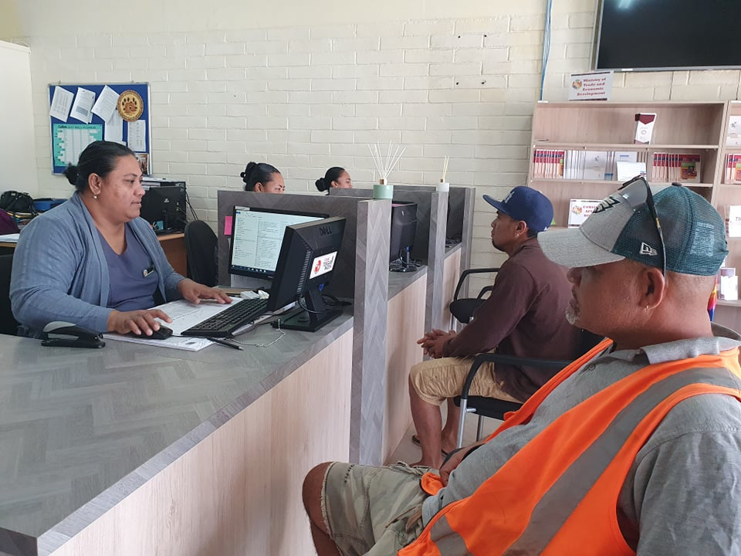
The Business Registry & Intellectual Property has four (4) subprograms with the following functions as follows;

Program 3: business registry & intellectual property

3.1 Customer Service Information: A business and intellectual Property service centre that is customer centric.
3.2 Business Registry: An improved business registry environment that is conductive for business startup and business growth
3.3 Innovation and Creativity: An innovative and creative IP environment that strengthens business competitiveness and increase demand for IP services
3.4 Business Compliance & Enforcement: Improved compliance of business with requirements prescribed under all business and intellectual property acts and regulations.

Reforms Undertaken
- Program 3, is a merge of Program 2 and 3 in the last Corporate Plan 2019/20, and the transfer of the of Business Enforcement from Program 1.
- The successful merge of Business Registry, Intellectual Property and Enforcement into one program has resulted in increased coordination and improved customer service and satisfaction which all contributes to “enabling business environment that is conducive to inclusive, sustainable and resilient economic growth”.

3.1 KEY DELIVERABLES/ACHIEVEMENTS

- Foreign Investment Act 2020 was passed by Parliament and received royal assent on 29th October,2020. Consultation on the Foreign Investment Regulation is ongoing.

- Arbitration Act 2020, has come into effect 25th February, 2021 purpose of this act includes the facilitation of “fair resolution of disputes by arbitration without unnecessary delay or expenses”

3.1.1 BUSINESS REGISTRATION

- Business Registry filing process has been reduced significantly from 2-3 weeks to 24hrs. It no longer requires manual checking and processing, and preparation of Certificates of Registration are all done electronically.

- Rrecorded an increase from last year in all the different registries (altogether an increase by 906 registrations) mandated under the Ministry as follows

High level Meetings
- Joined Heads of Intellectual Property Office Conference (HIPOC) for Pacific Island Countries
- Joined eHIPOC – Virtual Meeting with Heads of Intellectual Property Offices in the Pacific Island Countries on the Protection and Commercialization of Geographical Indications.

3.1.2 Trademark Registry

Total number of application1s at 4,143 and the total number of registrations at 2,850. The Trademark Registry has increased their target from one publication per quarter to one publication per month and this has resulted in an increase in the revenue generated from trademarks. Figure below shows the total number of applications filed, number of publications and number of registrations for each year for the last five years.

- Upgraded the main office Business Service Centre to be more customer centric.
- Established business service centre kiosk at Ha’apai so businesses can do searching and filings online for free

3.1.3 Ongoing work

- Industrial Property Automated System (IPAS) upgrade to a fully online system where applicants and local agents can fully file for protection of their trademarks, industrial design and patents online.
- Upgrade will include both the Industrial Design and Patents registries; in addition to the Madrid Protocol components to allow online filings through local agents.
- Auditing of Co-operative Societies

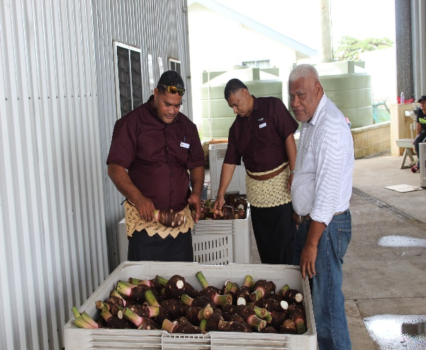

Program 4: business SUPPORT

The Business Support program has four (4 ) subprograms with the following functions as follows;
4.1 Community Business Development: Provision of targeted development supports that built the capacity of community business
4.2 Informal Sector Development: Provision of targeted supports that develops the capcity of MSMEs
4.3 Business Development: Provision of targeted development support that builds the capacity of local business
4.4 Export Development: Provision of exports supply chains support that caters for local producers and exporters.

Reforms Undertaken
- This program was formally known as Cooperatives and Business support; however program name was changed to reflect the Ministries commitment to be more inclusive such as including Community businesses.
- Program 4 will focus on developing the capacity of local producers & exporters and facilitating the supply chain for exports market.
Major Customers
The Key customers are local businesses and entrepreneurs both in the informal and formal sectors. This includes
- Existing and potential Informal MSMEs
- Existing and potenctial Cooperative and Credit Unions
- Agriculture small holder farmers
- Artisan fisherment and aquaculture farmers
- Women Entrepreneurs
- Handicraft Makers
- Youth Entrepreneurs
- Local manufacturers
- Local exporters

4.1 KEYDELIVERABLES/ACHIEVEMENTS

4.1.1 Developed, established and registered five (5) Farmers’ Cooperative Societies (FCS).
- 2 Farmers’ Cooperative Societies in Vava’u,
- 1 Farmers Cooperative Society Ha’apai,
- 1 Farmers Cooperative Society ‘Eua,
- 1 Farmers Cooperative Society Tongatapu.

4.1.2 Delivered Farmers’ Cooperative Societies Empowerment Programs (FCSEP) to five (5) Farmers’ Cooperative Societies mentioned above in 4.1.1.
- Cabinet approved the FCSEP for a total amount of $100,000 grant funding per FCS.
- FCS Development Plans were developed for the 5 FCS.
- Micro Financing Facilities were set up and fully established with the 5 FCS.
- Total grant amount for the FCSEP for this Financial Year is T$440,000

4.1.3 Deliver Capacity Building Programs through Trainings to micro MSMEs in the Informal Sector.
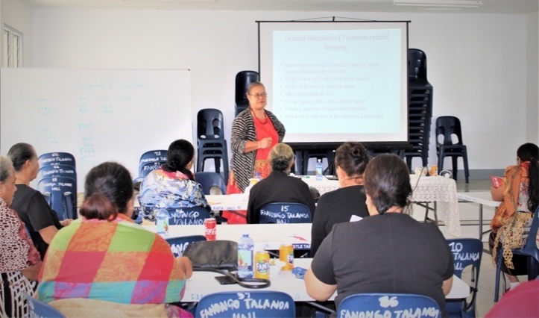
- Four (4) Micro MSME Trainings for the Western District Tongatapu. More than 120 micro MSME businesses participated.
- Five (5) Micro MSME Trainings for the Eastern District Tongatapu. More han 100 micro MSME participated.
- Three (3) Micro MSME Trainings for the Central District Tongatapu. More than 90 micro MSME businesses participated.

4.1.4 Developed and deliver MSMEs Product Development Projects for MSMEs.
- There were thirty-five (35) micro MSME businesses were recipients of the Product Development Project.
- A total of $2,000 project amount per project. The funding are paid to suppliers of tools, equipment and relevant inputs for the project.
- The total value of all the tools and equipment funded under the Product Development Project for the 35 projects is $70,000.

4.1.5 COVID-19 Business Recovery Assistance.
- Facilitated the processing of applications from more than 6,800 informal business entrepreneurs.

4.1.6 Deliver Capacity Building Programs through Trainings to micro MSMEs in the Informal Sector.
Three (3) Business Trainings were hosted and more than 30 local manufacturing Tonga Made businesses were attended the trainings.

4.1.7 Deliver Tonga Made Business Development Projects to local manufacturing businesses.
- Twenty three (23) local businesses were beneficiaries of the Tonga Made Product Development Project.
- A maximum amount of $5,000 were allocated per project to cover the costs of key operational gaps are identified that hindered the productivity of the businesses.
- The total project value for the 23 businesses was $115,000.

4.1.8 Deliver Business Support Assistances to Local Businesses.
- Towards the end of the Financial Year, the Division managed to deliver support to requests from six (6) local businesses.
- The total amount per request varies but the total value for the six projects were $192,400
- The request from businesses were including capital items, machineries, international freighting of products to overseas markets and freighting of inputs from overseas suppliers.
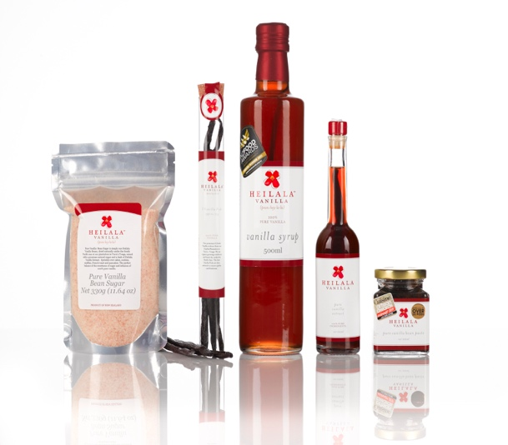
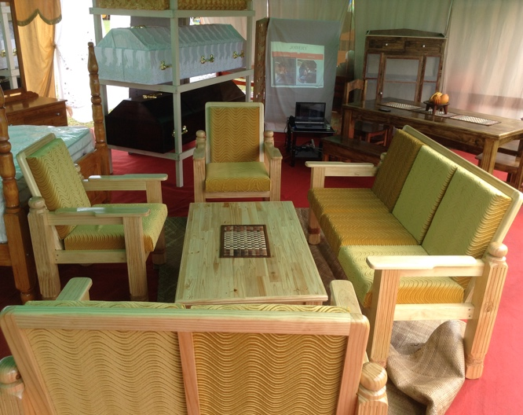

4.1.9 Marketing and Promotion of Local Businesses (Tonga Made)
- Develop one (1) new Buy Tonga Made Business Catalogues featuring all the local manufacturing businesses in Tonga
- Renew 5 billboard skins for the Buy Tonga Made billboards.
- Conducted 30 minutes live radio programs and live promotions via radio for 32 local businesses.
- Ongoing promotional via the Buy Tonga Made Facebook page.
- Ongoing promotions on Ministry’s website and other websites such as the Matangitonga website.
- More than 50 radio spots air time on the radios.
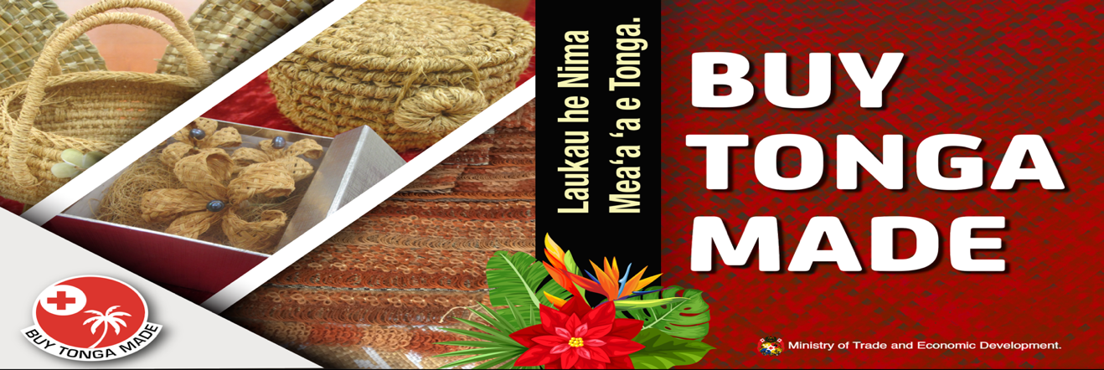

4.1.10 Development of new Pack Houses and renovations of existing Pack houses for processing and packing of exports.
- Procurement approved the project for construction of Vahe Hahake Pack House at Lapaha.
- Signed the Contract with the Construction Company (Puloka Construction) for building of the Pack House, to start in February 2021.
- Total projected amount for construction of Pack house – T$600,000.
- Also completed the renovation works for the ‘Alaki Fonua Pack House at MAFF Office at Alaki.
- The ‘Alaki Pack House was audited and passed by the HACCP Australia, fit and ready for processing and packing of watermelons for exports.

4.1.11 Facilitate the delivery of Exporters Local Freighting Subsidy Scheme (ELFSS) for local Exporter Companies.
- Cabinet approved the ELFSS in September 2020, for government through MTED to subsidize the freighting of produce from farmers in the outer islands targeted for exports.
- A total amount of $200,000 was approved by Cabinet for the ELFSS.
- Total of five (5) Exporter companies were benefitted from the ELFSS in this Financial Year.
- Four (4) companies are Agricultural Exporter companies and one (1) company is exporting scrape metals from the outer islands

4.1.12 Processing and Exporting produce from Farmers to Export Markets.
- Eight (8) fresh root crops containers were exported to MG Marketing NZ.
- Two (2) frozen root crops containers were exported to Quality Food Supplies Market in Australia.
- Seven (7) watermelon containers were exported to Fresh Direct Market NZ. However, three (3) containers were destroyed upon arrival into NZ due to the fruit fly interception from the watermelons from Tonga in October 2020.

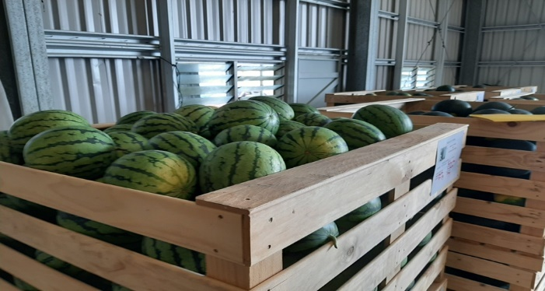
Figure 1Watermelons exported to NZ
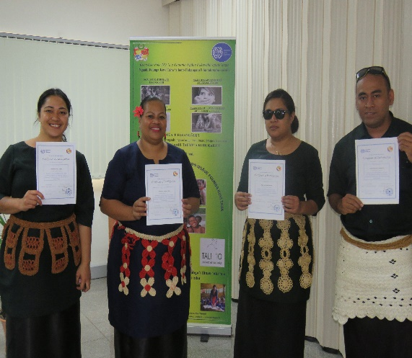

Program 5: LABOUR

The Labour program has three (3) subprograms with the following functions as follows;

Employment Regulatory Environment: Development of a strategy to improve the labour regulatory environment
  - Labour Market Research and Information: Develop and implement a strategy to provide accurate labour market information, including measurement of informal sector and informal employment for evidenced based policy interventions to reduce poverty.
  - Labour Standards & Decent Work: Develop and Implement a strategy to promote decent work and effective labour standards.

Reforms Undertaken
- This program had no changes compared to the last corporate plan (2019/2020).

Major Customers
The key clients of the Labour Program are stakeholders in the labour market. These include;

- Workers in the domestic labour market (both locals and foreign, and formal workers in both the formal and informal sector)
- Registered business and employers
- Workers association
- Employers’ association
- Unemployed working population

KEY DELIVERABLES/ACHIEVEMENTS

5.1.1 Approval of the Employment Relations Bill 2020.
Parliament approved the Employment Relations Bill 2020 thus marking a milestone in labour regulatory reform after 38 years of working to establish a legal framework to govern employment in Tonga. The Employment Relations Act 2020 has been tabled in the Privy Council.

5.1.2. SPECIAL CONSIDERATION FOR EMPLOYMENT VISA DURING COVID-19 LOCKDOWN.
The MTED and MFA officials continued its regular discussions of employment visa issues. A key outcome of these discussions was the consensus to find concessions within the internal policy to address the issue of applications for visas during the COVID-19 international travel restrictions and the prolonged closure of Tonga's borders. Consequently, the MTED waived its full assessment requirements for on-shore applications and recommended a short-term employment visa of up to 1 year for applicants. The division processed 57 visa applications where 36 were supported, 16 not supported and 5 carried forward to new financial year pending further review.

5.1.3 Development of a National Employment Policy for Tonga.
A seminar on the development of a high-level employment policy for stakeholders was successfully held from 29th June – 1st July 2021. A key outcome of the seminar was to develop a National Employment Policy (NEP) for Tonga, to assist recovery efforts and guide implementation of necessary active Labour market policies for development.
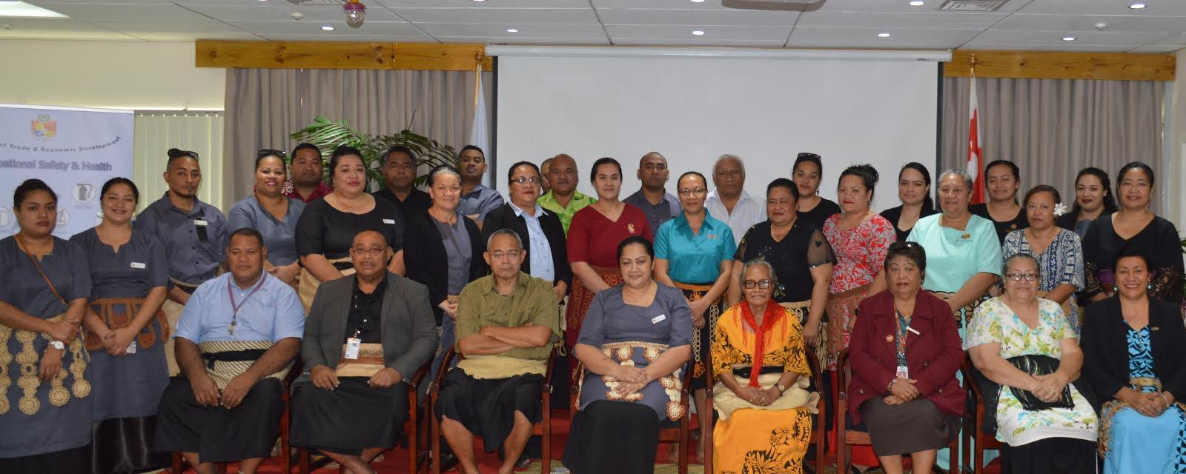

5.2.1. Development of a Labour Market Information System (LMIS) for Tonga.
The MTED endorsed the development of a labour market information system to enhance the collection of labour statistics for analysis and policy formulation. The MTED worked in partnership with the Statistics Department on the project. The project is expected to be completed in the next financial year.

5.2.2. Reestablishment of the Employment Services under the Labour Division of the MTED.
In response to COVID-19 impacts on employment, the MTED recognized the need to be implement active labour market policies to assist recovery efforts. A gap in providing employment services to the unemployed was identified and through mutual agreement with Ministry of Internal Affairs (MIA), the Employment Services was re-established in the Labour Division to provide much needed assistance to job seekers. During the first month over 100 job seekers registered with the Division.

The re-establishment of the Employment Services is to be formalized through the Cabinet for formal approval.

5.3.1. Ratification of the International Labour Organization's Worst Forms of Child Labour Convention (C182).
After becoming a member of the ILO in 2016, Tonga ratified its first ILO Convention on 4th August 2020. Tonga created history with its ratification of the Worst Forms of Child Labour Convention (C182) as it is the first ILO convention to have achieved universal ratification by all 187 members. Tonga's ratification is a significant step in commitment to take actions to prevent children from engaging in worst forms of child labour such as; all forms of slavery or practices such as the sale and trafficking of children, the procuring or offering of a child for prostitution or the production of pornographies, the use of a child for illicit activities in particular for the production and trafficking of drugs, and any work which by its nature is likely to harm the health, safety and moral of children

5.3.2. International Labour Organization (ILO) key projects.
In partnership with the ILO, the Labour Division secured various labour related projects for economic development in Tonga. These include;

(a) Rapid Assessment Report on the Impacts of COVID-19 on Businesses and Employment in Tonga.
A rapid assessment survey was rolled out in August & September 2020 to 1006 businesses (650 formal businesses and 356 informal businesses) that employed 7818 employees, to assess the impact of COVID-19 on businesses, jobs, and incomes. The report from the survey indicated varying levels of negative impacts on all three sectors - agricultural, services and manufacturing.
The report was launched in June 2021.

(b) Inclusive Economic Recovery through sustainable enterprises in the informal economies of Tonga.
Under a UN Multi Partner Trust Fund (MPTF) for COVID-19 recovery, Tonga became a successful recipient of funds and technical assistance to implement a business development support program for informal businesses in the creative and agricultural sectors.

(c) Technical training for Labour officials on international labour standards.
Applications from two (2) senior officials of the Labour Division were approved to participate in a virtual training to develop capacities in international labour standards. The study program was organized and implemented by the ILO Training Centre in Turin.

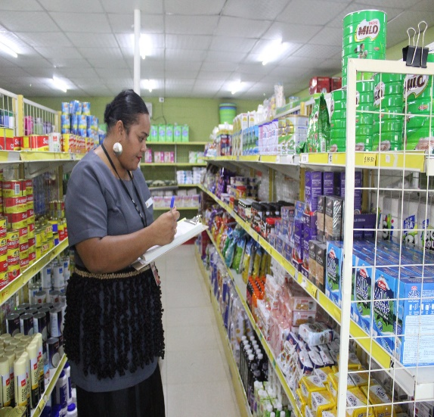

Program 6: consumer protection & fair trade

The Consumer Protection & Fair-Trade program has four (4) subprograms with the following functions as follows;

6.1 Consumer Protection Regulatory Environment: An institutional framework that promotes consumer welfare
6.2 Consumer Awareness & Education: Consumer Awareness and education programs to improve consumer knowledge, responsibilities and rights
6.3 Price Control: Facilitation of Competent Authority policy directions on regulated goods and services
6.4 Consumer Compliance & Enforcement: Enforcement and compliance requirements prescribed under the Consumer Protection Act, Price Control Act, and Weight & Measures Act

Reforms Undertaken
- The Consumer Protection & Fair-Trade program had three (3) sub programs In the previous financial year 2019/20. However, the Compliance & Enforcement sub-program was transferred from Program 1 to the Consumer Program and thus, an increase from 3 sub programs to 4 sub programs in this financial year.
Major Customers
The key clients of the Consumer Protection & Fair Trade Program are primarily consumers. However, the program also provides services to registered businesses including:
1. Distributors (wholesalers, importers)
2. Retailers (shops and service stations)
3. Regulated service providers (taxis, heavy trucks, buses)
4. Suppliers of petroleum and LPG
5. Power Utility

6.1 KEY DELIVERABLES/ACHIEVEMENTS

6.1.1 Public Awareness programs on Consumer Responsibilities and Rights
The Ministry conducted Community, Business and School Consultations in Vavaú during the month of August and Ha'apai in November 2020. This program enables awareness of their consumer rights and responsibilities and of the possible illegal practices of businesses and to understand that the Consumer Division is here to protect and empower consumers. Numbers of complaints has increased from 92 in Jan-June 2020 to 201 in the same period 2021. This indicates the awareness of the Consumers of the Redress Mechanism provided by the Government though the Ministry’s Consumer Protection and Fair Trade Division and Consumer Awareness of their rights promoted by the Division.

6.1.2 A Program for the enforcement of Price Control, Weight and Measures and Consumer Protection Act is developed and implemented

The enforcement team continued with its daily market surveillance program on retailers in ensuring compliance with our administered Act, the monthly test of service stations, 6 monthly test of weights and measures and certification of VGM (measures for export purposes) a requirement for the Marine Dept for all export products

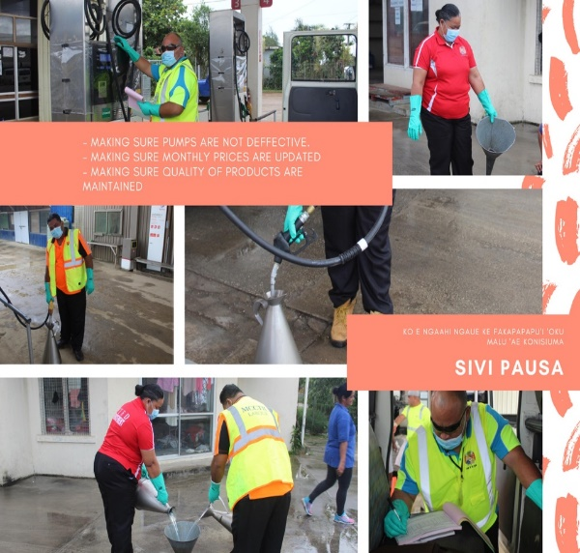
6.1.3 Review of the Bus Fare Rates and Taxi Rates.
The Ministry successfully implemented the review of the bus fare rates and taxi rates which are services endorsed by the TCA. The new bus fare rates has been gazetted and came into effect in August 2020. Billboards has been set up in both Bus Station for public information. The review of the taxi rates for Tongatapu and Vava'u was approved by TCA and new rates were effective on the 22nd March 2021. Public notice were issued to inform public of the updated rates and laminated copies of the revised taxi rates were distributed to all the taxi companies to have a copy in every taxi.
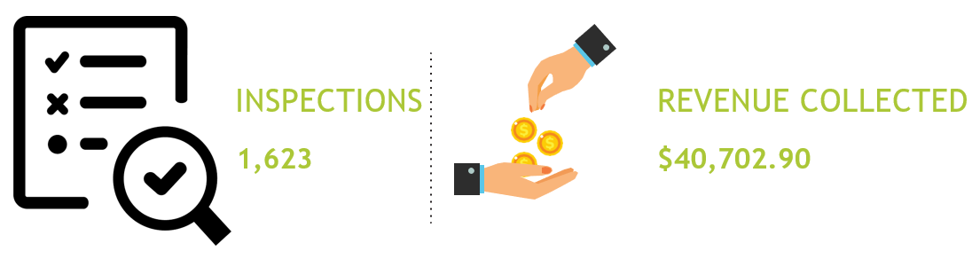

6.1.4 World Consumer Day

The Ministry joined World Consumer International in the recognition of the World Consumer Rights day on the 15th March annually. Specific activities to mark the World Consumer Rights day theme was a joint clean up with the No Pelesitiki Campaign along Nuku'alofa Waterfront and in Neiafu.

6.1.5 Tonga Competent Authority closely monitor the Petroleum and LPG Prices
As Secretariat to the Tonga Competent Authority, we successfully completed the timely pricing of petroleum products (petrol, diesel and kerosene) on a monthly basis as well as LPG on a Quarterly basis.
A total of 8 TCA meetings were implemented and 6 decisions were made through circulation. The Annual review report of the petroleum pricing template was endorsed by TCA and updated on the August and the 2021 Petroleum price review is underway. The 2020 Report provided Covid-19 adjustments to assist with the projected decrease in volume due to the Covid 19. TCA also approved the following:
- new effective dates for the release on the monthly petroleum and LPG quarterly to move from the 15th to the 18th of every month to avail enough time for Consumers to note the changes in prices
- new petrol standards for Tonga with low sulphur content reduction (Unleaded RON91 to unleaded RON95) effective on the May 2021 petroleum prices.

Program 7: trade & investment

The Investment and Export Promotion program previously known as the Trade & Investment Program has four (4) subprograms with the following functions as follows;

6.1 Trade Information and Market Research: New Exports products / markets
6.2 FDI Promotion and Facilitation: Increased foreign investment inflows
6.3 Trade Negotiation: International Trade Negotiations for market access opportunities
6.4 Export/Marketing and Promotion: Targeted Market Access Support

Reforms Undertaken
- The name of the Program was change to Investment & Export Promotion to highlight the significance of investment in this year’s GPA.
- It was considered important to separate the responsibilities of domestic activities from international activities.
- The Export Marketing and Promotion sub program was therefore transferred from the Business Support Program to Investment & Export Promotion.
Major Customers
The key clients of the Investment & Export Promotion Program are stakeholders who are engaged in international trade in goods and services. These include:

1. Small-scale exporters
2. Export-ready businesses who have not exported
3. Importers
4. Foreign investors
5. Domestic businesses / investors
6. Labour mobility workers / unemployed
7. General Public
8. WTO and FTA parties

7.1 KEY DELIVERABLES/ACHIEVEMENTS

7.1.1 Exporter Needs Assessment Survey
The division completed the Exporter Needs Assessment Survey in Tongatapu. The survey questionnaire was issued to importers, exporters and freight forwarders for completion. 33 businesses/exporters were respondent to the questionnaire- a response rate of 82.5%. Follow up face-to-face visit were conducted as to verify responses to the questions. Key recommendations from the survey includes but not limited to the following:
- Conduct market research in New Zealand, Australia, Hawaii and Samoa to explore opportunities for further expansion;
- Carry out a comprehensive review of the regulatory environment, laws, policies, regulations and rules pertaining to trade;
- Establish Exporters Association to address collective needs of members;
- Carry out value chain analysis of the fisheries sector and identify the strategic value options ans institutional support requirements;
- Strengthen Research & Development on new potential products for exports and new potential markets; and
- Establishment of cooling facilities and storage for commercials fishing operators

7.1.2 Profiling of investment opportunities project-Investment Promotion & Facilitation Strategy
The government of Tonga, through the Ministry of Trade & Economic Development (MTED) requested technical assistance of the Secretariat to provide capacity building for a project on Investment Facilitation, Investment Promotion and Profiling. The aim of this project was to identify the potential sectors of investments, developed the investment promotion & facilitation strategy and sector profiles for priority sectors followed by the development of a dedicated website for investment promotion and development of promotional materials for dissemination to interested investors.

The Ministry conducted a National workshop on Investment Promotion and Facilitation and met with stakeholders to formulate Tonga’s investment profiling and investment promotional materials in March-April 2021 to collect information from relevant stakeholders. The Division collated the feedback from key stakeholders and submitted to an Avasant consultant who undertakes delivery of Tonga’s Investment Promotion & Facilitation Strategy.

7.1.3 Pacific FDI Study

The Ministry completed the Pacific FDI Study for Tonga in collaboration with the ADB. The Division coordinated consultations with relevant Government Ministries on current investment policies implemented, business environment, review of foreign investment reserves and restricted list. The aim of the study is to identify the key constraints to foreign investment in line with the current review of the Foreign Investment Act and its regulation.

7.1.4 pacer plus agreement
Pacific Agreement on Closer Economic Relations (PACER) Plus entered into force 13 December 2020 after 60 days the eight signatory, which is Cook Island, submitted their instrument for ratification of the Agreement to the Depository, the Ministry of Foreign Affairs, Tonga. Eight (8) countries are Parties to the Agreement: Australia, Cook Islands, Kiribati, New Zealand, Niue, Samoa, Solomon Islands and Tonga.

7.1.5 Tonga Trade Policy Framework & E-commerce Readiness Assessment

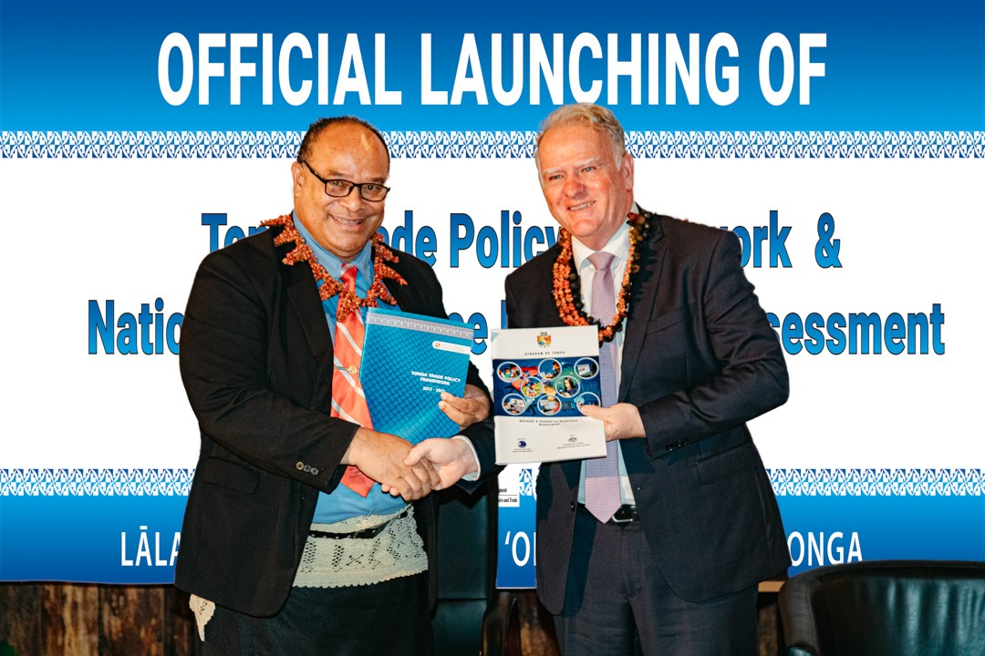
The Division successfully launched the Tonga Trade Policy Framework and E-commerce Readiness Assessment for Tonga in August, 2020. This Trade Policy Framework provides a structural context on how Tonga will manage its commercial activities in the country and with trading partners. It focuses in repositioning Tonga’s socio-economic development envisaged in the TSDF that contributes to the implementation of Tonga’s commitments on Trade related SDGs 8,9,14.6 and 17. The E-commerce Readiness Assessment was developed to provide an analysis of the current e-commerce situation, identify key constraints both internal and external, assess current strategies, weaknesses, gaps and opportunities. It also provides key policy reforms for Tonga to consider as they are keys to ensure Tonga is ready to trade in the e-commerce world.

Hon Pōhiva Tuʻiʻonetoa Prime Minister and Hon Mr Adrian Morrison, Australia High Commissioner to Tonga presided over the launching of the National E-commerce Assessment of Tonga and Tonga Trade Policy Framework. Credit: Pacific Islands Forum

Trade Facilitation Agreement (TFA) Implementation Roadmap
Completed the TFA Implementation Roadmap for Tonga. In partnership with the World Bank Group, the Trade & Investment Division secured secured this project for Tonga as part of our commitment under the WTO Trade Facilitation Agreement. The aim of this project was to identify key priorities for Tonga, build awareness of the content and obligations of the WTO Trade Facilitation Agreement; awareness of the notifications made by Tonga to the WTO on areas in which Tonga is (A) fully compliant; (B) not yet compliant but able to achieve compliance through its own efforts: and (c) not yet compliant and requiring external assistance in order to achieve compliance.Consultations with key stakeholders on the development of the TFA Implementation roadmap took place with special consideration on expedited shipment and release of medical supplies during the COVID-19 pandemic.
Business Support Assistances to Local Businesses/Exporters
The Business Support Fund program was a special assistance offered to local businesses and exporters towards the end of the Financial Year, to assist with promotion of local manufactured products and increase the volume of export. A total of 26 applications were received and endorsed by the Ministry with total project cost of TOP547,381.26. Applications for the funds were under 4 categories: Capital, International freight, marketing and promotion and other assistance.

Social Media Masterclass Virtual workshop
The Ministry in partnership with Pacific Trade and Invest Australia (PTI Australia) hosted a virtual workshop on Social Media Masterclass for Tongan businesses and exporters on the 8th September 2020. This workshop highlighted the importance of e-commerce and digital connection to boost trade especially during the COVID-19 pandemic. Mrs. Heather Porter, an expert on online marketing from Australia, delivered the workshop. More than 20 participants from private companies, small businesses and relevant government ministries participated in the training.

Significant Issues and Challenges

- Staffing capacity, while some divisions are adequately staffed, some divisions operated with minimal staff members, amongst these divisions is the Labour and Trade division.
- The lack of available and relevant trainings to upskill staff, especially the need for Senior Officers for the Outer Island branches.
- Changing priorities due to the COVID-19 Pandemic
- Has resulted in the delay/change of work priorities across line divisions. Some of which are external factors that directly affect the ministry, for instance the exporting of agricultural crops is adversely affected by the unpredictable changes and cancellation in the shipping schedules.
- Restrictions in the

Disclosure and Legal Compliance

Conclusion

Annex 1: Ministry’s Legislations
 | Legislations | Main Purpose
1 | - Business License Act 2002  - Business License (Amendment) Act 2007  - Business License (Amendment) Act 2010  - Business License (Amendment) Act 2012 | To provide for the licensing of all business activities in the country.
 | - Business License Regulations 2007  - Business License (Amendment) Regulations 2010  - Business License Regulations 2012 | For the administration and enforcement of the Business License Act and amendments.
2 | - Registration of Business Name Act 2002  - Registration of Business Name (Amendment) Act 2012 | To provide for the registration of all registered businesses business names.
 | - Registration of Business Name Regulation 2008  - Registration of Business Name Regulations 2014 | For the administration of Business Names registration.
3 | - Companies Act 1995  - Companies (Amendment No. 1) Act 1999  - Companies (Amendment) Act 2001  - Companies (Amendment) Act 2009 | For the incorporation of companies.
 | - Companies Regulations 1999  - Companies (Liquidation) Regulations 1999  - Companies (Amended) Regulations 2003  - Companies (Amended) Regulations 2009  - Companies (Amended) Regulations 2010 | For the administration of the Companies Act.
4 | - Foreign Investment Act 2002  - Foreign Investment (Amendment) Act | Investment promotion and attraction and to protect local investors/Tongans’ businesses in activities that are reserved for Tongans.
 | - Foreign Investment Regulation 2006  - Foreign Investment Regulation | For the administration of the Foreign Investment Act.
5 | Consumer Protection Act 2000 | To protect consumer interests and to establish measures to enable consumers to obtain redress.
6 | Prices & Wages Control Act 1988 | To establish the Competent Authority and to ensure measures to regulate prices and wages.
7 | Weights & Measures Act 1988  - Weights & Measures (Amendment) Act 1997 Weights & Measures (Amendment) Act 1998 | To provide a uniform standard and units of measurement to be used in the country.
8 | Incorporated Societies Act 1988 | For incorporation of non-profit organization.
 | - Incorporated Societies Regulations  - Incorporated Societies (Amendment) Regulations 2010 | For the administration of the Incorporated Societies Act.
9 | Charitable Trust Act 1993 | For registration of a trust board for charitable purposes.
 | Charitable Trust Regulations 2010 | For the administration of the Charitable Trust Act.
10 | - Industrial Property Act 1994  - Industrial Property (Amendment) Act 1999  - Industrial Property (Amendment) Act 2002  - Industrial Property (Amendment) Act 2009 | For the protection of industrial properties, namely- patent, integrated circuit, industrial design and trademarks.
 | - Industrial Property Regulations 2000  - Industrial Property (Amendment) Regulations 2010 | For the administration of the industrial property Act-patent, integrated circuit, industrial design and trademarks.
11 | Copyrights Act 2002 | For the protection of literary and artistic works.
12 | Geographical Indications Act 2002 | For the protection of particular products which are of such qualities that corresponds to a specific place of origin.
 | Geographical Indications Regulations 2008 | For the administration of the Geographical Indication Act.
13 | Protection of Lay-out Designs (Topographies) of Integrated Circuits Act 2002 | For the protection of plans which show the three dimensional location of the electronic components of an integrated circuit.
 | Protection of Layout Designs (Topographies) of Integrated Circuits Regulations 2009 | To regulate the Protection of Lay-out Designs Act.
14 | Protection against Unfair Competitions Act 2002 | For the protection against Unfair Competitions between businesses.
15 | Personal Property Securities Act 2010 | For the registration of personal properties using as collateral to ensure first priorities
 | Personal Property Securities Regulations 2009 | For the administration of Personal Property Securities Act.
16 | Cooperative Societies Act 1973 | To regulate the operations of Cooperative Societies in Tonga.
17 | Credit Unions Act 1977 | To regulate the operations of Credit Unions in Tonga.

